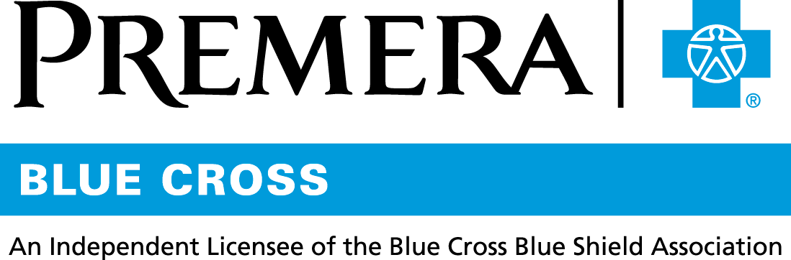

Content 3 Ways
TOPIC: Vitamin D testing

Instructions

Copy and paste the below content that works best for the way you want your employees to receive the information. The content is presented three ways:
- Long: Designed for your employee newsletter or email
- Medium: Ready for your employee website or as a brief reminder
- Short: Great for an employee text message or your employee television

Premera does not authorize any changes to text, unless specifically identified in the document. Employers will be solely responsible for all consequences due to any unauthorized changes made to the provided templates.

1. Long:
For your employee newsletter or email

Vitamin D screening not recommended in the general population
What is vitamin D and what does it do?
Vitamin D is a nutrient your body needs for good health. Vitamin D protects you from developing osteoporosis, a disease that weakens bones and makes them more likely to break. In addition, vitamin D also supports immune health, muscle function, and brain cell activity.

What is the current vitamin D testing recommendation?
Vitamin D testing is not recommended for the general population. Your provider may consider checking your vitamin D level if you are among the small number of people who are high risk for significant vitamin D deficiency due to having certain chronic health conditions, specific symptoms, or other risk factors. Treating slightly low vitamin D levels for otherwise healthy individuals does not require testing. In most cases, a routine test will not be covered by insurance plans unless a medically necessary health condition demands it.

How do I make sure I’m getting enough vitamin D?
Through a combination of sun exposure, diet, and supplements as needed.

Get consistent amounts of sun exposure: Your body makes vitamin D when your bare skin is exposed to the sun. In areas with strong mid-day sunlight, five to thirty minutes of sun exposure daily to twice a week in the spring, summer, and fall may produce all the vitamin D needed throughout the year. People living in areas with limited strong mid-day sunlight will likely benefit from some supplementation. Note: ultraviolet radiation from sunshine can cause skin cancer, so it’s important to limit how much time you spend in the sun.

Eating a varied diet: Some vitamin D can be found in milk, orange juice, yogurt (many of which are often vitamin D fortified), beef liver, and fatty fish (trout, tuna, and mackerel). Also, plant-based milks, breakfast cereals, fish liver oils, egg yolks, cheeses, and mushrooms all contain some vitamin D. However, it is hard to get the full amount of vitamin D that you need through diet alone.

Supplements as needed: Your primary care provider can help you determine if and how much supplementation you personally may need. In routine cases, testing is not required to start supplementation. Note: vitamin D can interact or interfere with other medicines and supplements, so talk to your healthcare provider before taking supplements.

The most powerful tool on your healthcare journey is a primary care provider (PCP) who knows you well and can guide and support your care with regular preventive visits. No provider? Use the Premera Find a Doctor tool to locate a provider near you.

2. Medium:
For your employee website or as a brief reminder

Vitamin D screening not recommended in the general population

What is the current vitamin D testing recommendation?
Vitamin D testing is not recommended for the general population. Your provider may consider checking your vitamin D level if you are among the small number of people who are high risk for significant vitamin D deficiency due to having certain chronic health conditions, specific symptoms, or other risk factors. Treating slightly low vitamin D levels for otherwise healthy individuals does not require testing. In most cases, a routine test will not be covered by insurance plans unless a medically necessary health condition demands it.

How do I make sure I’m getting enough vitamin D?
Through a combination of sun exposure, diet, and supplements as needed.

Get consistent amounts of sun exposure: Your body makes vitamin D when your bare skin is exposed to the sun. In areas with strong mid-day sunlight, five to thirty minutes of sun exposure daily to twice a week in the spring, summer, and fall may produce all the vitamin D needed throughout the year. People living in areas with limited strong mid-day sunlight will likely benefit from some supplementation. Note: ultraviolet radiation from sunshine can cause skin cancer, so it’s important to limit how much time you spend in the sun.

Eating a varied diet: It is hard to get the total amount of vitamin D that you need through diet alone. Most milk, cereal, and yogurt are fortified with vitamin D. Some foods such as fatty fish, egg yolks, and cheeses also naturally contain vitamin D.

Supplements as needed: Your primary care provider can help determine if and how much supplementation you may need. In routine cases, testing is not required to start supplementation. Note: vitamin D can interact or interfere with other medicines and supplements, so talk to your healthcare provider before taking one.

Regular preventive care visits with a primary care provider (PCP) who knows you well can help you find and address issues before they become serious. No provider? No problem. Use the Premera Find a Doctor tool.

3. Short:
For an employee text message or your employee television

Most people don’t need to be tested for vitamin D deficiency and get their vitamin D through a combination of sun exposure, diet, and supplements as needed. In most cases, a routine test will not be covered by insurance plans unless a medically necessary health condition demands it. Your primary care provider will help determine if and how much supplementation is needed or whether you are at high risk for severe deficiency.

