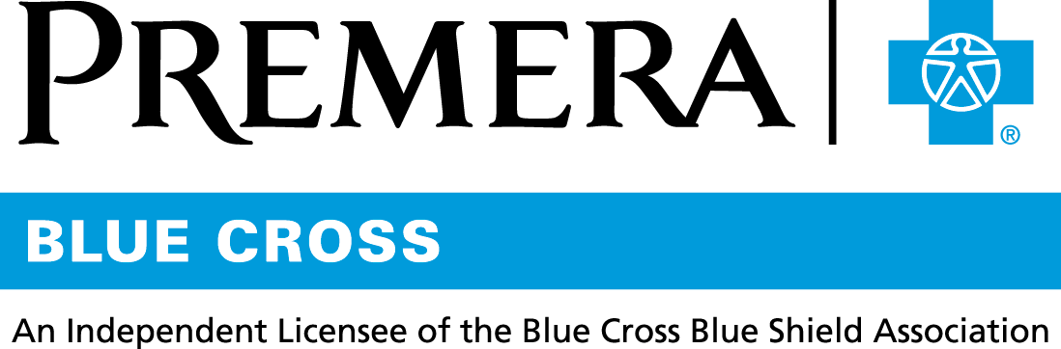

Content 3 Ways
TOPIC: Rx Savings Solutions

Instructions

Copy and paste the below content that works best for the way you want your employees to receive the information. The content is presented 3 ways:
- Long: Designed for your employee newsletter or email
- Medium: Ready for your employee website or as a brief reminder
- Short: Great for an employee text message or your employee television

Premera does not authorize any changes to text, unless specifically identified in the document. Employers will be solely responsible for all consequences due to any unauthorized changes made to the provided templates.

1. Long:
For your employee newsletter or email

Pharmacy savings with Rx Savings Solutions
Introducing Rx Savings Solutions, a free-to-you benefit that helps you and others on your Premera Blue Cross health plan easily find the lowest-price options for prescriptions drugs.
This service is securely linked to your health plan, so everything is personalized for your medications. All you need to do is activate your account.
How it works:
- Check out what lower-cost prescriptions may be available under your health plan and compare prices at different pharmacies.
- Rx Savings Solutions will handle everything with your doctor and pharmacy to switch your prescription to a lower-cost pharmacy.
- You’ll receive an email (or text message if you opt in to receive texts) anytime you can spend less, taking the burden off you to find the lowest price on your medications.
Activate your account at www.myrxss.com/premera
Questions about Rx Savings Solutions? Call 800-268-4476 (TTY: 800-877-8973) or email support@rxsavingssolutions.com, Monday through Friday, 5 a.m. to 6 p.m. Pacific Time.
Rx Savings Solutions is an independent company that provides prescription discount services on behalf of Premera Blue Cross.

2. Medium:
For your employee website or as a brief reminder

Pharmacy savings with Rx Savings Solutions
Rx Savings Solutions (RxSS) is a free-to-you benefit that helps you and others on your Premera Blue Cross health plan easily find the lowest-price options for your prescription drugs. RxSS will send you an email or text message when there’s a savings opportunity. You can also compare drug costs on their website.
Activate your free RxSS account at www.myrxss.com/premera
Questions about Rx Savings Solutions? Call 800-268-4476 (TTY: 800-877-8973) or email support@rxsavingssolutions.com, Monday through Friday, 5 a.m. to 6 p.m. Pacific Time.
Rx Savings Solutions is an independent company that provides prescription discount services on behalf of Premera Blue Cross.

3. Short:
For an employee text message or your employee television

Save money on your prescriptions with Rx Savings Solutions. Receive an email or text when you can save. Go to www.myrxss.com/premera to activate your free account.

