  
    My Account
    Covid-19
    Find Care

Schedule your no-cost checkup

Preventive care can help identify problems early before they become more serious and harder to treat. Schedule your no-cost* checkup today.

No-cost preventive care

  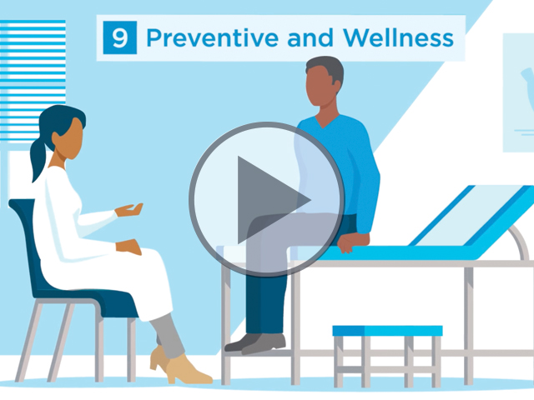
  UNDERSTAND YOUR BENEFITS
  Get the care you need while keeping your costs as low as possible.
  How health plans work

  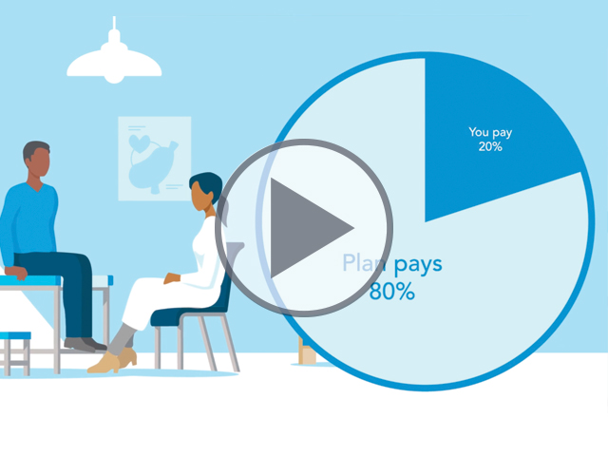
  WHAT YOU PAY, WHAT YOUR PLAN PAYS
  Get comfortable using your health plan by understanding a few key health insurance terms and how much you will pay versus how much your plan will pay.
  Health plan costs

  
  SAVE MONEY ON PRESCRIPTIONS
  From mail order delivery to choosing generic drugs, Premera members have easy ways to save money on prescription medications.
  Prescription savings

  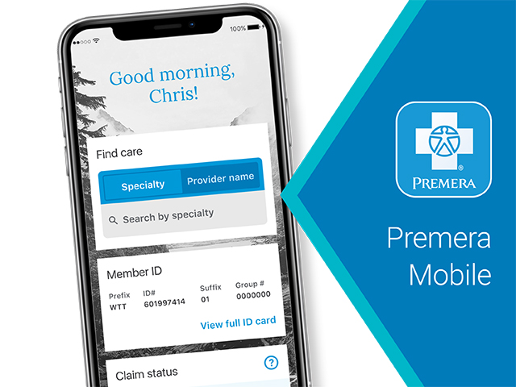
  PREMERA MOBILE APP
  Track costs, view your ID card,
  and find a doctor.
  Download on iOS or Android.

  
  PREMERA MYCARE APP
  Access virtual care providers anytime, anywhere from one convenient app.
  Download on iOS or Android.

*During your visit, your doctor may order tests and lab work that are not covered by your preventive benefits. Discuss all tests with your doctor as you may be required to pay a share of these costs.
Premera Blue Cross is an Independent Licensee of the Blue Cross Blue Shield Association
PO Box 327, Seattle, WA 98111
Discrimination is Against the Law
Premera Blue Cross complies with applicable Federal and Washington state civil rights laws and does not discriminate on the basis of race, color, national origin, age, disability, sex, gender identity, or sexual orientation. 038503 (07-01-2021)
Español | 中文

059058 (04-10-2022)
PBC Washington

