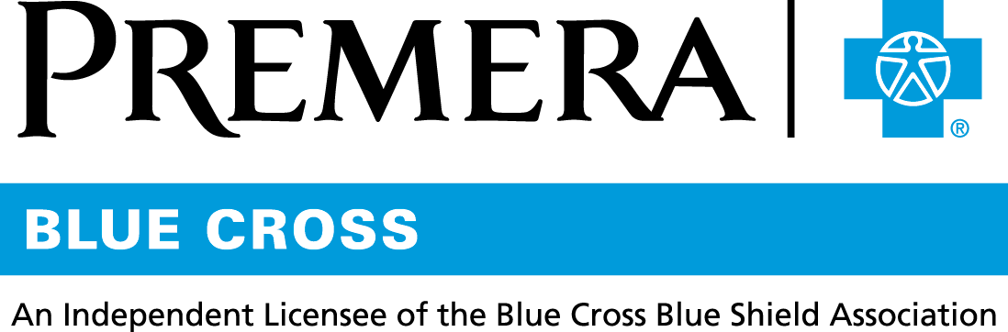

Content 3 Ways
TOPIC: Livongo—Chronic condition management

Instructions

Copy and paste the below content that works best for the way you want your employees to receive the information. The content is presented 3 ways:
- Long: Designed for your employee newsletter or email
- Medium: Ready for your employee website or as a brief reminder
- Short: Great for an employee text message or your employee television

Premera does not authorize any changes to text, unless specifically identified in the document. Employers will be solely responsible for all consequences due to any unauthorized changes made to the provided templates.

1. Long: 142 words
For your employee newsletter or email

Live the healthier life you want

Livongo provides monitoring and health management support to Premera members who have been diagnosed with common chronic conditions, including diabetes, pre-diabetes, and hypertension.

Livongo overview
- Free to Premera Blue Cross members
- Combines advanced technology with personalized coaching
- Empowers members to make better decisions by providing digital tools and real-time tips
- Connects members to Certified Diabetes Educators, 24-hours a day, 365 days a year

Livongo by condition
Diabetes
- Unlimited blood glucose test strips
- Connected glucose meter
- Personalized insights

Diabetes prevention
- One-on-one coaching
- Connected scale
- Community support

Hypertension
- One-on-one coaching
- Connected blood pressure monitor
- Real-time tips

Find out more about the program and sign up at welcome.livongo.com/premera.

Livongo may be reaching out to you directly in the coming weeks.

If you have any questions, please call Premera customer service at 800-722-1471 (TTY: 711) Monday through Friday, 5 a.m. to 8 p.m. Pacific Time.

On behalf of Premera, Livongo is an independent company that provides diabetes management services.
Premera Blue Cross is an independent licensee of the Blue Cross Blue Shield Association.

2. Medium: 113 words
For your employee website or as a brief reminder

Livongo—Living the healthier life you want

Livongo provides monitoring and health management support to people diagnosed with common chronic conditions, including diabetes, pre-diabetes, and hypertension.

This no-cost benefit:
- Combines advanced technology with personalized coaching
- Empowers members to make better decisions by providing digital tools and real-time tips
- Connects members to Certified Diabetes Educators, 24-hours a day, 365 days a year

Condition support
Diabetes
- Unlimited blood glucose test strips
- Connected glucose meter
- Personalized insights

Diabetes prevention
- One-on-one coaching
- Connected scale
- Community support

Hypertension
- One-on-one coaching
- Connected blood pressure monitor
- Real-time tips

Livongo may be reaching out to you directly in the coming weeks.

To find out more about Livongo:
- Visit welcome.livongo.com/premera
- Call 800-722-1471 (TTY: 711)

On behalf of Premera, Livongo is an independent company that provides diabetes management services.
Premera Blue Cross is an independent licensee of the Blue Cross Blue Shield Association.

3. Short: 19 words
For an employee text message or your employee television

Dealing with diabetes, pre-diabetes, or hypertension? Visit welcome.livongo.com/premera to find out about your free monitoring and health support benefit.

