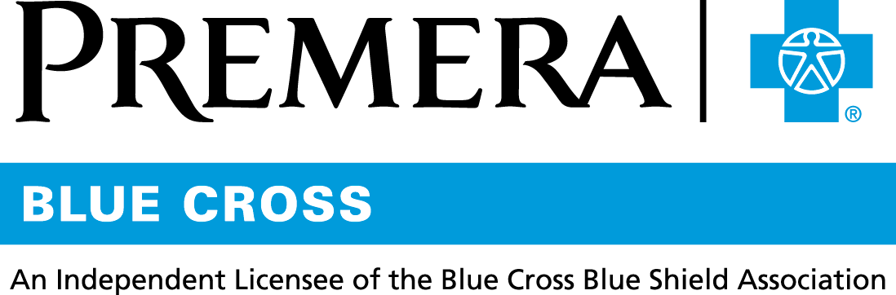

Content 3 Ways
TOPIC: Opioids

Instructions

Copy and paste the below content that works best for the way you want your employees to receive the information. The content is presented 3 ways:
- Long: Designed for your employee newsletter or email
- Medium: Ready for your employee website or as a brief reminder
- Short: Great for an employee text message or your employee television

Premera does not authorize any changes to text, unless specifically identified in the document. Employers will be solely responsible for all consequences due to any unauthorized changes made to the provided templates.

1. Long: 152 words
For your employee newsletter or email

Safeguarding members in pain
Over 90 Americans die each day as a result of opioid abuse and addiction. About half of these deaths are caused by misuse of opioid prescriptions.

Premera Blue Cross is helping prevent opioid addiction at the time of prescription. You can be sure that if your doctor prescribes opioids to control pain, the prescription you receive minimizes the risk for misuse or addiction.

Our opioid prescription policies:
- Align with the latest guidelines from the Centers for Disease Control and Prevention (CDC)
- Were developed with input from healthcare providers

Premera takes great pride in serving the communities across the United States. As a health plan, we are working to reduce the opioid crisis by:
- Helping reduce the likelihood of addiction at the time of prescription
- Providing treatment options to members with opioid use disorder

TIP: Have leftover opioids or other prescription medicine? Here’s how to safely dispose of it.

2. Medium: 131 words
For your employee website or as a brief reminder

Safeguarding members in pain
Premera Blue Cross is helping prevent opioid addiction at the time of prescription. You can be sure that if your doctor prescribes opioids to control pain, the prescription you receive minimizes the risk for misuse or addiction.

The new policies:
- Align with the latest guidelines from the Centers for Disease Control and Prevention (CDC)
- Were developed with input from healthcare providers

Premera takes great pride in serving the communities across the United States. As a health plan, we are working to reduce the opioid crisis by:
- Helping reduce the likelihood of addiction at the time of prescription
- Providing treatment options to members with opioid use disorder

3. Short: 39 words
For an employee text message or your employee television

Premera Blue Cross is working to help prevent opioid addiction at the time of prescription. You can be sure that if your doctor prescribes opioids to control pain, the prescription you receive minimizes the risk for misuse or addiction.

045417 (04-16-2018)

