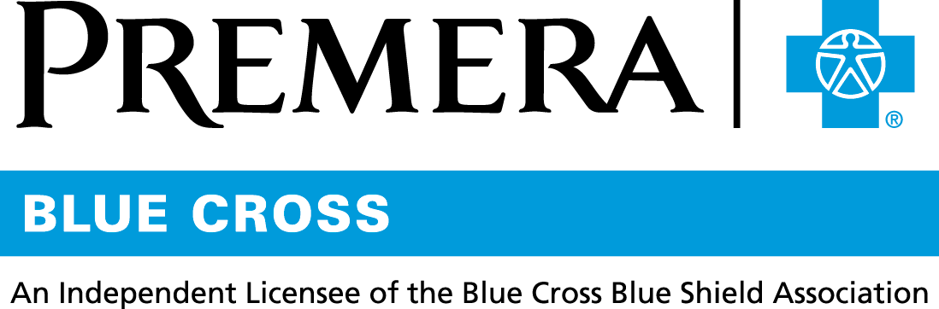

Content 3 Ways
TOPIC: HSA On Demand®

Instructions

Copy and paste the below content that works best for the way you want your employees to receive the information. The content is presented 3 ways:
- Long: Designed for your employee newsletter or email
- Medium: Ready for your employee website or as a brief reminder
- Short: Great for an employee text message or your employee television

Premera does not authorize any changes to text, unless specifically identified in the document. Employers will be solely responsible for all consequences due to any unauthorized changes made to the provided templates.

1. Long: 210 words
For your employee newsletter or email

Not enough in your HSA? No problem!
Your Health Savings Account (HSA) comes with a special feature called HSA On Demand®, which allows you to access your full year’s HSA contributions at any time in the plan year to cover eligible medical expenses as needed.

Think of it like overdraft protection. This way, if you have medical expenses that occur early in the year before your account balance is built up, you have funds to cover the cost. Contributions continue as scheduled to repay the amount you use.

Immediate need. Immediate funds. Interest free. HSA On Demand is automatic. You don’t have to do anything to use it or to repay it. Funding will automatically kick in if you need it, interest free, based on your future contributions. Any HSA On Demand funds will be repaid automatically through future contributions.

Easy to Track. In your online ConnectYourCare account, you will see the total potential value of your HSA, which includes your contributions, employer contributions <Adjust this as needed for your situation.>, investments holdings, and available HSA On Demand® funds.

Now you have coverage when you need it. It’s that simple.

ConnectYourCare is an independent company that provides healthcare funding account administration. It does not provide Blue Cross Blue Shield products or services and is solely responsible for their own services.

2. Medium: 157 words
For your employee website or as a brief reminder

Not enough in your HSA? No problem!
HSA On Demand® allows you to access your full year’s HSA contributions at any time of the plan year to cover eligible medical expenses as needed.

Think of it like overdraft protection. If you have medical expenses that occur early in the year before your account balance is built up, you have funds to cover the cost.

Immediate need. Immediate funds. Interest free. Funding will automatically kick in if you need it, interest free, and contributions will continue as scheduled.

Easy to Track. In your online ConnectYourCare account, you will see the total potential value of your HSA, which includes contributions, investments holdings, and available HSA On Demand® funds.

Now you have coverage when you need it. It’s that simple.

ConnectYourCare is an independent company that provides healthcare funding account administration. It does not provide Blue Cross Blue Shield products or services and is solely responsible for their own services.

3. Short: 40 words
For an employee text message or your employee television

Your Health Savings Account (HSA) through ConnectYourCare comes with a special feature called HSA On Demand®, which allows you to access your full year’s HSA contributions at any time in the plan year to cover eligible medical expenses as needed.

