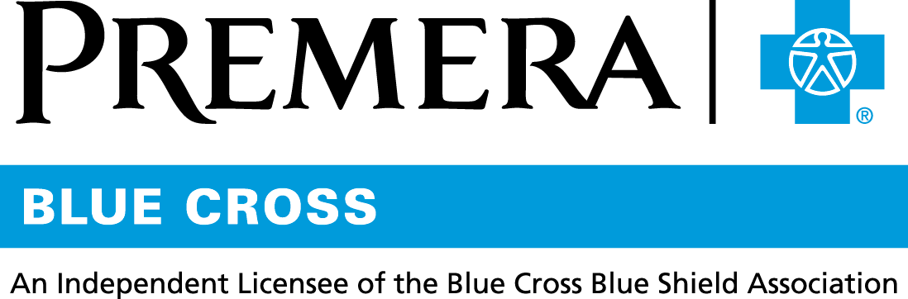

Content 3 Ways
TOPIC: Specialty Pharmacy (Accredo exclusive)

Instructions

Copy and paste the below content that works best for the way you want your employees to receive the information. The content is presented 3 ways:
- Long: Designed for your employee newsletter or email
- Medium: Ready for your employee website or as a brief reminder
- Short: Great for an employee text message or your employee television

Premera does not authorize any changes to text, unless specifically identified in the document. Employers will be solely responsible for all consequences due to any unauthorized changes made to the provided templates.

1. Long: 146 words
For your employee newsletter or email

Specialty pharmacy
The Specialty Pharmacy Program is part of your Premera Blue Cross health plan. It is for people who take specialty drugs, which:
- Treat complex or rare conditions
- Are usually self-injected
- Need special handling, such as refrigeration
People often need extra help to learn how to take and manage a specialty drug. Premera’s specialty pharmacy partner, Accredo, fills prescriptions and also:
- Has a pharmacist-led care team you can talk to for condition-specific information
- Works with you to make sure you’re taking your drugs correctly
- Offers clinical support for dosing and potential side effects
- Ensures safe, prompt delivery of specialty drugs (Accredo can’t send drugs to a PO Box.)

Want to know more about your Specialty Pharmacy benefit? Contact Premera Customer Service:
- By phone at 800-722-1471, 5 a.m. to 8 p.m. Monday through Friday, Pacific Standard Time
- Online: Just sign into your account at premera.com and select Secure Inbox.

Accredo is an independent company providing specialty pharmacy services to Premera Blue Cross and Premera Blue Cross Blue Shield of Alaska members.

2. Medium: 110 words
For your employee website or as a brief reminder

Specialty pharmacy
The Specialty Pharmacy Program is part of your Premera Blue Cross health plan. Specialty drugs:
- Treat complex or rare conditions
- Are usually self-injected
- Need special handling, such as refrigeration
People often need extra help to learn how to take a specialty drug. Premera’s specialty pharmacy partner, Accredo, fills prescriptions and delivers them safely and promptly.
Accredo also has a pharmacist-led care team you can talk to about:
- How to take your drugs correctly
- Dosing and side-effect details
- Condition-specific information

Questions? Contact Premera Customer Service:
- By phone at 800-722-1471, 5 a.m. to 8 p.m. Monday through Friday, Pacific Standard Time
- Online: Just sign into your account at premera.com and select Secure Inbox.

Accredo is an independent company providing specialty pharmacy services to Premera Blue Cross and Premera Blue Cross Blue Shield of Alaska members.

3. Short: 41 words
For an employee text message or your employee television

The Specialty Pharmacy Program is part of your Premera Blue Cross health plan. (Specialty drugs treat complex or rare conditions and need special handling, such as refrigeration.) Find out more about this program and our specialty pharmacy partner, Accredo, at premera.com.

044579 (04-16-2018)

