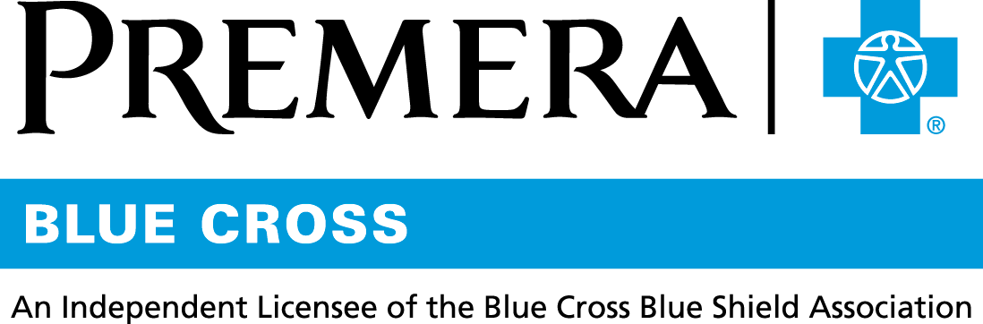

Content 3 Ways
TOPIC: Essentials Pharmacy Plan

Instructions

Copy and paste the below content that works best for the way you want your employees to receive the information. The content is presented 3 ways:
- Long: Designed for your employee newsletter or email
- Medium: Ready for your employee website or as a brief reminder
- Short: Great for an employee text message or your employee television

Premera does not authorize any changes to text, unless specifically identified in the document. Employers will be solely responsible for all consequences due to any unauthorized changes made to the provided templates.

1. Long: 128 words
For your employee newsletter or email

Essentials: Curbing the impact of rising drug costs

Drug prices are steadily going up. Even with a good pharmacy plan, some prescriptions can feel overpriced.

The pharmacy plan included with your health plan is called Essentials. This benefit covers prescription drugs for your basic pharmacy needs. It offers quality medicine at a reasonable cost and at least one option in each drug class.

Essentials helps keep your costs as low as possible by focusing on high-value drugs that are approved by the U.S. Food and Drug Administration (FDA).

Not included in Essentials are:
- Low-value, high-cost drugs
- Drugs with lower-cost, over-the-counter alternatives
- Drugs not approved by the FDA
- Drugs sold at inflated prices

Tip: To find out more about your pharmacy benefits, sign in to your account at premera.com.

2. Medium: 119 words
For your employee website or as a brief reminder

Essentials: Curbing the impact of rising drug costs

Drug prices are steadily going up. Even with a good pharmacy plan, some prescriptions can feel overpriced.

The pharmacy plan included with your health plan is called Essentials. This benefit covers prescription drugs for your basic pharmacy needs. It offers quality medicine at a reasonable cost and at least one option in each drug class.

Essentials helps keep your costs as low as possible by focusing on high-value drugs that are approved by the U.S. Food and Drug Administration (FDA). It does not cover:
- Low-value, high-cost drugs
- Drugs with lower-cost, over-the-counter alternatives
- Drugs not approved by the FDA
- Drugs sold at inflated prices

Tip: To find out more about your pharmacy benefits, sign in to your account at premera.com.

3. Short: 49 words
For an employee text message or your employee television

The Essentials pharmacy plan offers high-value prescriptions at a sensible cost. It meets basic pharmacy needs by covering at least one drug in each drug class. Sign in to your account at premera.com to find out more about your benefits. And remember: Many prescriptions now have low-cost, over-the-counter alternatives.

042977 (10-15-2018)

