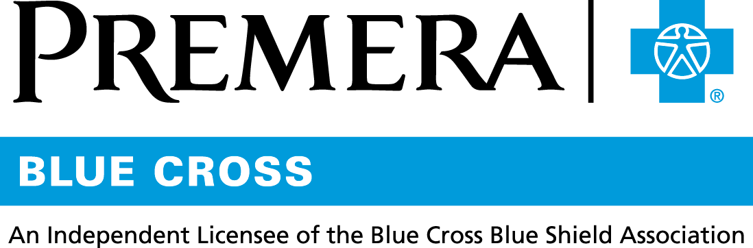

Content 3 Ways
TOPIC: Be nicotine free

Instructions

Copy and paste the below content that works best for the way you want your employees to receive the information. The content is presented 3 ways:
- Long: Designed for your employee newsletter or email
- Medium: Ready for your employee website or as a brief reminder
- Short: Great for an employee text message or your employee television

Premera does not authorize any changes to text, unless specifically identified in the document. Employers will be solely responsible for all consequences due to any unauthorized changes made to the provided templates.

1. Long: 126 words
For your employee newsletter or email

Quit nicotine at no cost to you
Studies show if you have a support system when quitting nicotine, you are more likely to stay on track.
Let Premera help, with dependency programs and prescription drugs—some at no cost to you.
Nicotine dependency programs, offered by approved in-network healthcare providers, are covered in full by our Premera health plan. Find an approved provider by calling the customer service number on your Premera ID card.
Certain costs for nicotine dependency drugs are also covered by our health plan. If you get approved drugs from an in-network pharmacy with a written prescription, you pay no coinsurance or copay.
Tip: Talk to your doctor about nicotine dependency programs in your area and prescription drugs that might be right for you.

2. Medium: 106 words
For your employee website or as a brief reminder
Quit nicotine at no cost to you

Studies show if you have a support system when quitting nicotine, you are more likely to stay on track. Let Premera help, with dependency programs and prescription drugs—some at no cost to you.

Nicotine dependency programs, offered by approved in–network healthcare providers, are covered in full by our Premera health plan. Find an approved provider by calling the customer service number on your Premera ID card.

Certain costs for nicotine dependency drugs are also covered by our health plan. If you get approved drugs from an in-network pharmacy with a written prescription, you pay no coinsurance or copay.

3. Short: 36 words
For an employee text message or your employee television

Did you know nicotine dependency programs offered by approved in-network healthcare providers are covered in full by our Premera health plan? Find an approved provider by calling the customer service number on your Premera ID card.

