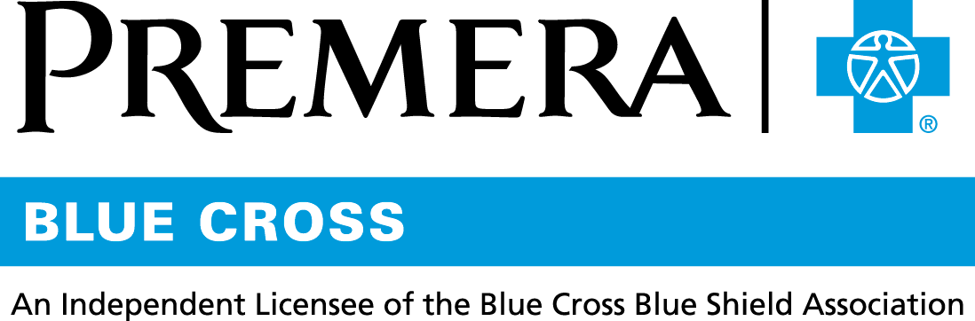

Content 3 Ways
TOPIC: Blood Pressure

Instructions

Copy and paste the below content that works best for the way you want your employees to receive the information. The content is presented 3 ways:
- Long: Designed for your employee newsletter or email
- Medium: Ready for your employee website or as a brief reminder
- Short: Great for an employee text message or your employee television

Premera does not authorize any changes to text, unless specifically identified in the document. Employers will be solely responsible for all consequences due to any unauthorized changes made to the provided templates.

1. Long: 164 words
For your employee newsletter or email

4 tips to keep your blood pressure down

High blood pressure is known as the “silent killer.” Many people don’t know they have it. When left untreated, high blood pressure can lead to stroke, heart attack, and heart or kidney failure.

Follow these 4 lifestyle tips to keep your blood pressure in check:
- Get to know your blood pressure by getting it checked
- Maintain a healthy weight
- Exercise regularly
- Eat a diet rich in fruits and vegetables, whole grains, and foods low in salt

Did you know?
Blood pressure is always given as two numbers.
- Systolic pressure, the top (and higher) number, refers to the pressure of blood in the artery when the heart contracts.
- Diastolic pressure, the bottom (and lower) number, refers to the pressure of blood in the artery when the heart relaxes between beats.

If your blood pressure reading is 120/80, you say it is “120 over 80.”

Tip
You can get your blood pressure checked during a preventive care visit!

2. Medium: 86 words
For your employee website or as a brief reminder

4 tips to keep your blood pressure down

High blood pressure is known as the “silent killer.” Many people don’t know they have it. When left untreated, high blood pressure can lead to stroke, heart attack, and heart or kidney failure.

Follow these lifestyle tips to keep your blood pressure in check:
- Get to know your blood pressure by having it checked
- Maintain a healthy weight
- Exercise regularly
- Eat a diet rich in fruits and vegetables, whole grains, and foods low in salt

Tip:
You can get your blood pressure checked during a preventive care visit.

3. Short: 16 words
For an employee text message or your employee television

Is your blood pressure high, low or just right? Find out at a preventive care visit!

