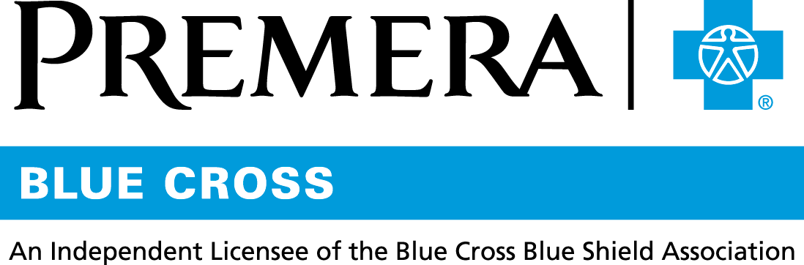

Content 3 Ways
TOPIC: Preventive Dental

Instructions

Copy and paste the below content that works best for the way you want your employees to receive the information. The content is presented 3 ways:
- Long: Designed for your employee newsletter or email
- Medium: Ready for your employee website or as a brief reminder
- Short: Great for an employee text message or your employee television

Premera does not authorize any changes to text, unless specifically identified in the document. Employers will be solely responsible for all consequences due to any unauthorized changes made to the provided templates.

1. Long: 139 words
For your employee newsletter or email

Protect your smile and your health with preventive dental care
Good oral hygiene and professional dental care can help prevent cavities and gum disease. They can also lower your risk of certain health conditions, such as cardiovascular disease.
With regular dental care, you’re also likely to reduce the chance that you’ll need more complex—and more expensive—dental procedures in the future.
Your dental plan covers certain preventive services like routine exams, cleanings, and x-rays.
Make an appointment to see your dentist every 6 months to ensure early diagnosis and treatment of any dental issues you may have—and to keep your smile bright and healthy!

Looking for a dentist? Sign in at premera.com and search with the Find a Doctor tool.
Tip: Regular dental care can help reduce the need for more complex—and expensive—dental procedures in the future.

2. Medium: 103 words
For your employee website or as a brief reminder

Protect your smile and your health with preventive dental care

Good oral hygiene and professional dental care can help prevent cavities and gum disease. They can also lower your risk of certain health conditions, such as cardiovascular disease.

With regular dental care, you’re also likely to reduce the chance that you’ll need more complex—and more expensive—dental procedures in the future.

Your dental plan covers certain preventive services like routine exams, cleanings, and x-rays.

Make an appointment to see your dentist every 6 months to ensure early diagnosis and treatment of any dental issues you may have—and to keep your smile bright and healthy!

3. Short: 18 words
For an employee text message or your employee television

Good oral hygiene and professional dental care can prevent cavities and lower your risk of certain health conditions.

