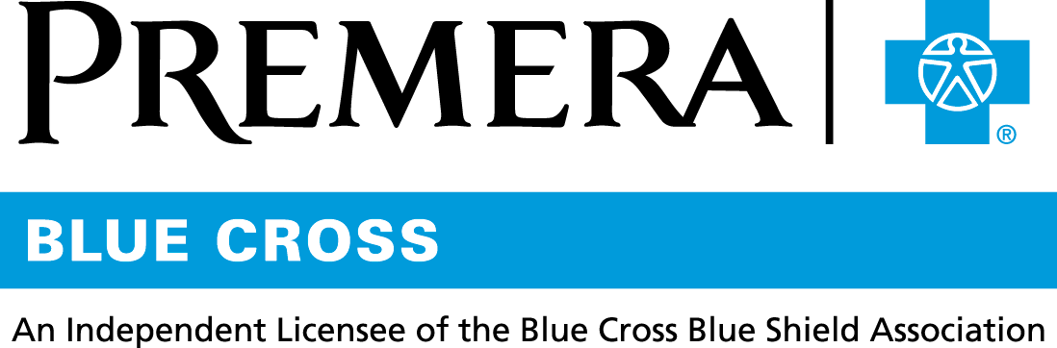

Content 3 Ways
TOPIC: My Rx Choices®

Instructions

Copy and paste the below content that works best for the way you want your employees to receive the information. The content is presented 3 ways:
- Long: Designed for your employee newsletter or email
- Medium: Ready for your employee website or as a brief reminder
- Short: Great for an employee text message or your employee television

Premera does not authorize any changes to text, unless specifically identified in the document. Employers will be solely responsible for all consequences due to any unauthorized changes made to the provided templates.

1. Long: 127 words
For your employee newsletter or email

How much could you save on prescription drugs? Find out now!
It’s no surprise—pharmacy costs are increasing every year. To help you get the most for your money, do some comparison shopping with My Rx Choices® on premera.com.

My Rx Choices is an online price-comparison tool. It allows you to:
- Compare costs of your current medications
- Find generic or lower-cost, preferred brand-name alternatives
- See how much you could save with a lower-cost drug choice

You also can save on prescriptions through Express Scripts® Home Delivery, part of your pharmacy benefit.

Tip: When you set up a member account at premera.com, you’ll have access to several other online tools. To get the most out of the online tools, be sure to sign in to your member account.

2. Medium: 83 words
For your employee website or as a brief reminder

How much could you save on prescription drugs? Find out now!

To help you get the most for your money, do some comparison shopping with My Rx Choices® on premera.com.

My Rx Choices is an online price-comparison tool. It allows you to:
- Compare costs of your current medications
- Find generic or lower-cost, preferred brand-name alternatives
- See how much you could save with a lower-cost drug choice

You also can save on prescriptions through home delivery by Express Scripts®, part of your pharmacy benefit.
3. Short: 21 words
For an employee text message or your employee television

My Rx Choices® is an online price-comparison tool that helps you get the most for your money. Find it on premera.com.

