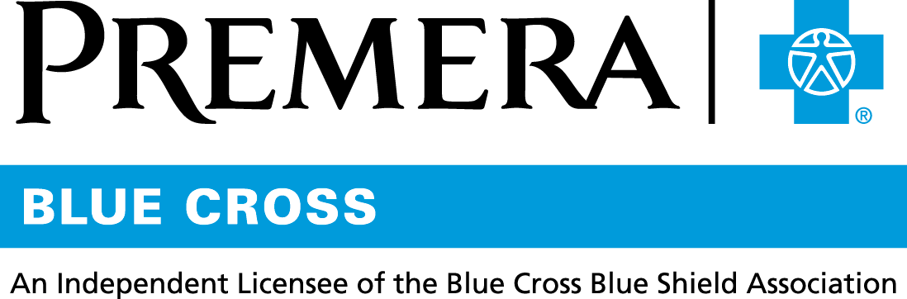

Content 3 Ways
TOPIC: Mobile App

Instructions

Copy and paste the below content that works best for the way you want your employees to receive the information. The content is presented 3 ways:
- Long: Designed for your employee newsletter or email
- Medium: Ready for your employee website or as a brief reminder
- Short: Great for an employee text message or your employee television

Premera does not authorize any changes to text, unless specifically identified in the document. Employers will be solely responsible for all consequences due to any unauthorized changes made to the provided templates.

1. Long: 193 words
For your employee newsletter or email

Premera has a mobile app for you

Get your health plan info on the go with the Premera mobile app.

You’ll have convenient, anywhere access to your health plan information with Premera’s redesigned mobile app. With the app in hand, you can:

- Find Care: Know where to go for care. Find in-network doctors, hospitals, urgent care, and more.
- Access your ID card: Forgot your insurance card? Don’t worry. You can use your digital ID card to show your proof of coverage.
- Check claims: View detailed claims information, including when we receive your claim, when we pay it, and what the provider may bill you.
- Track your spending: Know exactly how close you are to meeting your deductible and out-of-pocket maximum.
- Use touch ID to sign in to your Premera account: You won’t have to remember a password to sign in.
- Be on top of prescription and pharmacy needs: Seamlessly move from the Premera mobile app to the ExpressScripts app, where you can set up reminders, order and refill prescriptions, and check drug prices.

Download the mobile app today so it’s ready when you need it. It’s free to download on Android and iOS.

You can also check claims, see your spending, and access ExpressScripts when you sign in to your account at premera.com.

2. Medium: 166 words
For your employee website or as a brief reminder

Get your health plan info on the go with the Premera mobile app
You’ll have convenient, anywhere access to your health plan information with Premera’s redesigned mobile app. With the app in hand, you can:

- Find Care: Find in-network doctors, hospitals, urgent care, and more.
- Access your ID card: Use your digital ID card to show your proof of coverage.
- Check claims: View detailed claims information, including when we receive your claim, when we pay it, and what the provider may bill you.
- Track your spending: Know exactly how close you are to meeting your deductible and out-of-pocket maximum.
- Use touch ID to sign in to your Premera account: You won’t have to remember a password to sign in.
- Be on top of prescription and pharmacy needs: Seamlessly move from the Premera mobile app to the ExpressScripts app.

Download the mobile app today so it’s ready when you need it.
Tip: You can download the Premera Mobile app for free. It’s available on Android and iOS.
3. Short: 27 words
For an employee text message or your employee television

With Premera Mobile you can find doctors, show your ID card, check claims, and more. Download the mobile app today so it’s ready when you need it.

