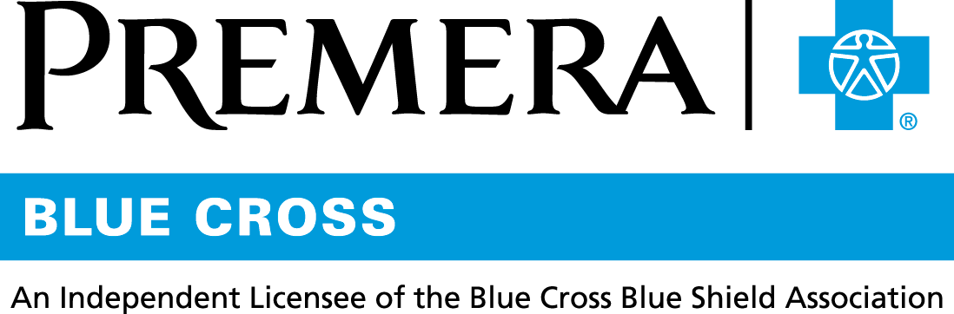

Content 3 Ways
TOPIC: Flexible Spending Accounts

Instructions

Copy and paste the below content that works best for the way you want your employees to receive the information. The content is presented 3 ways:
- Long: Designed for your employee newsletter or email
- Medium: Ready for your employee website or as a brief reminder
- Short: Great for an employee text message or your employee television

Premera does not authorize any changes to text, unless specifically identified in the document. Employers will be solely responsible for all consequences due to any unauthorized changes made to the provided templates.

1. Long: 157 words
For your employee newsletter or email

Flexible spending accounts—a great way to set aside money for certain expenses

There are two types of FSAs:
- Healthcare: For eligible medical, dental, and vision expenses, such as plan deductibles, copays, and coinsurance.
- Dependent care: For eligible dependent care expenses, such as daycare for a child.

With an FSA, you:
- Save on taxes: You can automatically deposit funds from your paycheck pre-tax into your FSA.
- Pay for eligible expenses: These may include medical, dental, and vision care costs, copays, coinsurance, prescriptions, and some over-the-counter medications.

Paying for eligible expenses is simple
- Use your healthcare payment card like you would a debit card to pay for qualified out-of-pocket medical costs.
- Or pay with your own credit card, cash, or check. Then sign in at premera.com and file the claim for reimbursement by check or direct deposit.

Tip: To manage your FSA online, sign in at premera.com and select Personal Funding Accounts under Manage My Account.

2. Medium: 102 words
For your employee website or as a brief reminder

Flexible spending accounts—a great way to set aside money for certain expenses

With an FSA, you:
- Save on taxes: You can automatically deposit funds from your paycheck pre-tax into your FSA.
- Pay for eligible expenses: These may include medical, dental, and vision care costs, copays, coinsurance, prescriptions, and some over-the-counter medications.

Paying for eligible expenses is simple
- Use your healthcare payment card like you would a debit card to pay for qualified out-of-pocket medical costs.
- Or pay with your own credit card, cash, or check. Then sign in at premera.com and file the claim for reimbursement by check or direct deposit.

3. Short: 38 words
For an employee text message or your employee television

Flexible Spending Accounts (FSAs) offer a great way to help you save on taxes and pay for qualified healthcare expenses. To manage your FSA online, log in at premera.com and select Personal Funding Accounts under Manage My Account.

