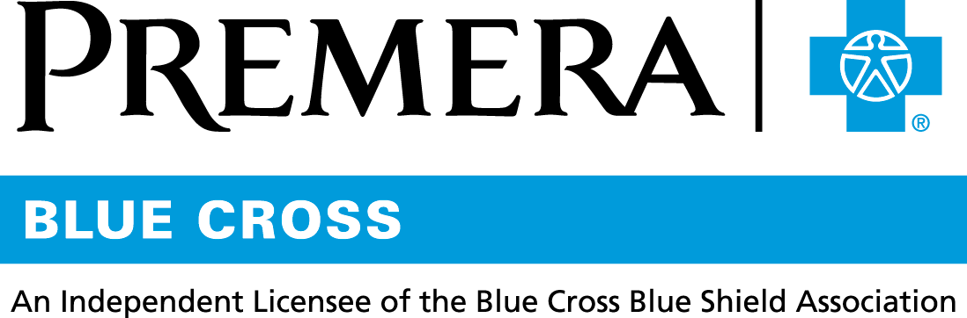

Content 3 Ways
TOPIC: Health Savings Account

Instructions

Copy and paste the below content that works best for the way you want your employees to receive the information. The content is presented 3 ways:
- Long: Designed for your employee newsletter or email
- Medium: Ready for your employee website or as a brief reminder
- Short: Great for an employee text message or your employee television

Premera does not authorize any changes to text, unless specifically identified in the document. Employers will be solely responsible for all consequences due to any unauthorized changes made to the provided templates.

1. Long: 289 words
For your employee newsletter or email

Health Savings Account—A smart choice for now and for your future

When you choose a Health Savings Account (also known as an HSA) with your Premera health plan, you’re making a smart choice.

Here are some of the great features of an HSA:
- Triple tax benefit
  - Funds are deducted from your paycheck pre-tax
  - Funds can be used to pay for IRS-approved, non-taxed medical expenses
  - Your money grows tax-free
- The money is always yours—even if you change jobs, switch health plans, or retire—it is not taxed if used for qualified medical expenses

Once you have passed the Customer Identification Program process, your HSA is automatically opened for you at a federally insured bank by ConnectYourCare (CYC). CYC is an independent company that administers health savings accounts on behalf of Premera Blue Cross.

Once you are enrolled in an HSA, visit the FAQ page to get answers to your questions and learn how to get the most benefit from your plan.

Tip: An HSA also provides you with the opportunity to earn money through investments. Log in to your account at premera.com to learn more.

Premera Blue Cross is not an administrator, trustee, or fiduciary of any health savings account which may be used by a plan member in conjunction with a health plan. This material is not intended to be tax or legal advice. The reader should consult with his or her own tax advisor to determine the tax implications of purchasing the products discussed herein. Advice, if any, included in this material was not intended or written by Premera to be used, and it cannot be used, by any taxpayer for the purpose of avoiding penalties that may be imposed on the taxpayer.

2. Medium: 164 words
For your employee website or as a brief reminder

Health Savings Account – A smart choice for now and for your future

When you choose a Health Savings Account (also known as an HSA) with your Premera health plan, you’re making a smart choice. You get both broad health benefits and a savings account to help pay for medical expenses.

Here are some of the great features of an HSA:
- Triple tax benefit
  - Funds are deducted from your paycheck pre-tax
  - Funds can be used to pay for IRS-approved, non-taxed medical expenses
  - Your money grows tax-free
- The money is always yours—even if you change jobs, switch health plans, or retire—it is not taxed if used for qualified medical expenses

Tip: Your HSA is automatically opened for you at a federally insured bank by ConnectYourCare (CYC) once you have passed the Customer Identification Program process. CYC is an independent company that administers health savings accounts on behalf of Premera Blue Cross. Log in to your account at premera.com to learn more.

3. Short: 33 words
For an employee text message or your employee television

Save smart—use your Health Savings Account to save pre-tax money for paying your medical expenses. The money is always yours to keep, even if you change jobs or health plans, or retire.

