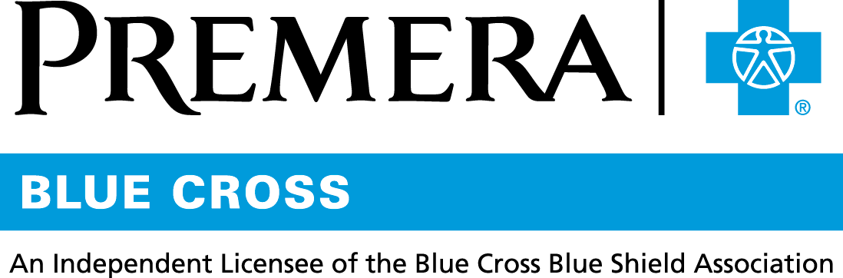

Content 3 Ways
TOPIC: Generic and Mail-Order Drugs

Instructions

Copy and paste the below content that works best for the way you want your employees to receive the information. The content is presented 3 ways:
- Long: Designed for your employee newsletter or email
- Medium: Ready for your employee website or as a brief reminder
- Short: Great for an employee text message or your employee television

Premera does not authorize any changes to text, unless specifically identified in the document. Employers will be solely responsible for all consequences due to any unauthorized changes made to the provided templates.

1. Long: 192 words
For your employee newsletter or email

Save with generic and mail-order drugs

Keep more money in your wallet by choosing generic and mail-order drugs.

What are generic drugs?
Generic drugs have the same quality, strength, purity, and stability as their brand-name counterparts. They are just as effective, but they are substantially discounted from the branded price. That means you save money.

The next time you need a new prescription, be sure to ask your doctor if a generic drug is available.

What are mail-order drugs?
For prescriptions you take regularly (these are often called maintenance medications), you’ll save time and money by signing up for mail-order. You’ll incur fewer copays when you are prescribed a 60-day or 90-day supply. Plus, you won’t have to make as many trips to the pharmacy or spend time waiting for your prescription to be filled.

Prescriptions are delivered to your home in a weather-resistant pouch and shipped with free standard delivery.

To get started with receiving your maintenance medications by mail, sign in to premera.com and select Pharmacy Services under Member Services for more information.

Tip: You also can sign up for home delivery of prescriptions by going direct to the Express Scripts website.

2. Medium: 98 words
For your employee website or as a brief reminder

Save with generic and mail-order drugs

Keep more money in your wallet by choosing generic and mail-order drugs.

Generic drugs are the same as brand-name drugs, but they cost much less. Be sure to ask your doctor if a less expensive generic drug is available the next time you need a new prescription.

Mail order is ideal for prescriptions you take regularly. You can save on prescriptions through Express Scripts home delivery, part of your pharmacy benefit.

Tip: To get the most out of your pharmacy benefit, sign in at premera.com and select Pharmacy Services under Member Services.

3. Short: 17 words
For an employee text message or your employee television

Keep more money in your wallet by asking for generic drugs or signing up for mail order.

