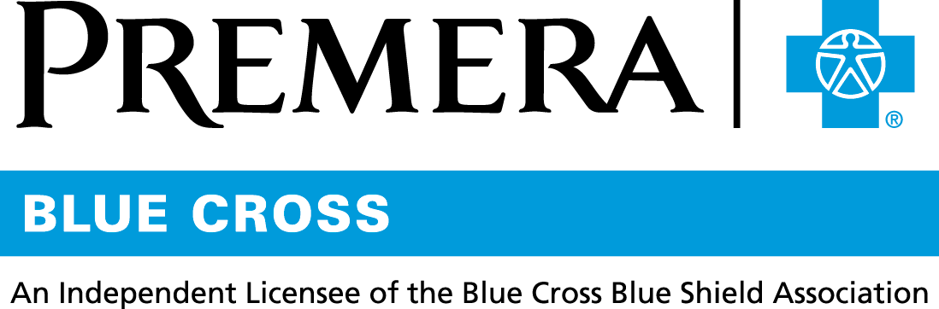

Content 3 Ways
TOPIC: PPO vs. Health Plan with HSA

Instructions

Copy and paste the below content that works best for the way you want your employees to receive the information. The content is presented 3 ways:
- Long: Designed for your employee newsletter or email
- Medium: Ready for your employee website or as a brief reminder
- Short: Great for an employee text message or your employee television

Premera does not authorize any changes to text, unless specifically identified in the document. Employers will be solely responsible for all consequences due to any unauthorized changes made to the provided templates.

1. Long: 246 words
For your employee newsletter or email

What’s the right medical plan for you?
If you’re trying to choose between a preferred provider organization (PPO) plan and a high-deductible health plan with a health saving account (HSA), use the tips below to help you decide what’s best for you.

Consider a plan with an HSA if . . .
You want to lower your taxable income while saving for future healthcare expenses. The HSA is flexible: you can take the account with you if you leave the company for any reason, and you can start or stop your contributions at any time.

Consider a PPO plan if . . .
You want to manage your care with the least amount of effort. There are no claims or IRS tax forms to file and no HSA to manage.

Consider a PPO plan or a plan with an HSA if . . .
You want preventive care services at no cost. All Premera health plans cover preventive care at no additional cost for services such as annual checkups and routine screenings!

Before making a final decision, consider:
- Your anticipated medical expenses for the coming plan year
- If you have money set aside to pay out-of-pocket expenses if you need care
- How important it is for you to have the flexibility to see any provider you choose
- The amount of money you are comfortable paying per paycheck

Note: This information is not intended to be tax or legal advice. Consult your own tax advisor to determine any tax implications of a health plan with an HSA.

2. Medium: 178 words
For your employee website or as a brief reminder

Need help choosing the right medical plan for you?

Use this chart to help you understand the difference between a preferred provider organization (PPO) plan and a high-deductible health plan with a health savings account (HSA).

Do you want: | Then consider: |  | Why?
 | A PPO plan | A plan with an HSA
Lower taxable income  while saving for future  healthcare expenses? |  | X | You can save money  for future healthcare  expenses and save on taxes. The HSA is flexible: you can take the account with you if you leave the company for any reason, and you can start or stop your contributions at any time.
To manage your care with the least amount of effort? | X |  | There are no claims to file and no HSA to manage.
Preventive care services  at no cost? | X | X | All Premera health plans cover preventive care at no additional cost.

This chart provides general information. It is not intended to be tax or legal advice.

Before making a final decision, also consider the amount of money you are comfortable paying per paycheck for your healthcare expenses.

3. Short: 10 words
For an employee text message or your employee television

All Premera health plans cover preventive care at no additional cost.

