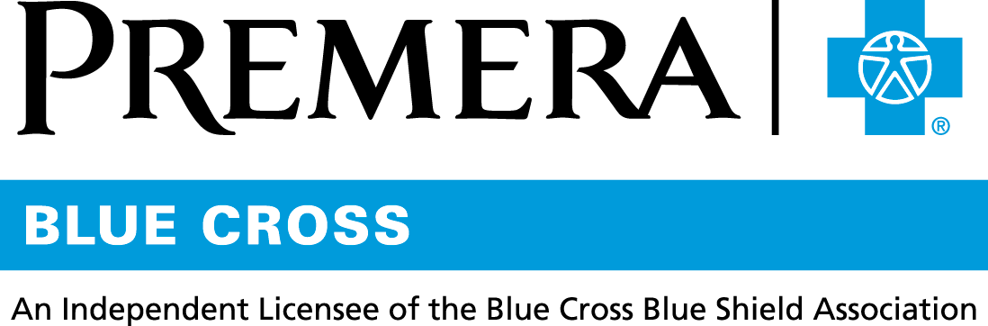

Content 3 Ways
TOPIC: Electronic EOBs

Instructions

Copy and paste the below content that works best for the way you want your employees to receive the information. The content is presented 3 ways:
- Long: Designed for your employee newsletter or email
- Medium: Ready for your employee website or as a brief reminder
- Short: Great for an employee text message or your employee television

Premera does not authorize any changes to text, unless specifically identified in the document. Employers will be solely responsible for all consequences due to any unauthorized changes made to the provided templates.

1. Long: 155 words
For your employee newsletter or email

Insight into your explanation of benefits
When you receive healthcare, your provider sends the bill (known as a claim) to Premera. When we pay the claim, we send you an explanation of benefits or EOB. (Don't worry: It's not a bill.)

The EOB explains how your benefits were applied to a particular claim, including the following:
- Date of service
- Amount billed and amount paid by your plan
- Amount you owe
- Amount credited toward your deductible

EOB to-do list
To stay on top of your expenses:
- Review each EOB closely
- Compare it to your provider’s receipt or bill
- Keep the EOB for at least 2 years

Skip the snail mail
You can get your EOBs quicker by going paperless. We'll send you an email each time a new EOB is available for you to view securely online. To sign up now:
- Log in at premera.com
- Under My Account, select Account Settings to turn on Paperless EOBs.

2. Medium: 112 words
For your employee website or as a brief reminder

Insight into your explanation of benefits
When you receive healthcare, your provider sends the bill (claim) to Premera. When we pay the claim, we send you an explanation of benefits or EOB. Don't worry: It's not a bill.

The EOB explains how your benefits were applied to a particular claim, including the following:
- Date of service
- Amount billed and amount paid by your plan
- Amount you owe
- Amount credited toward your deductible

Skip the snail mail
Sign up to get your EOBs securely online and you’ll receive an email when you have a new EOB to view.
- Log in at premera.com
- Under My Account, select Account Settings to turn on Paperless EOBs.

3. Short: 42 words
For an employee text message or your employee television

An explanation of benefits (EOB) isn’t a bill. It explains how your benefits were applied to a particular claim. To get EOBs online, instead of in your mailbox, login at premera.com. Under My Account, select Account Settings to turn on Paperless EOBs.

